Note: Student is required to attach this completed Lab Supervisor Acknowledgement to SRE Application form.
The goal of the INBRE Student Research Experience (SRE) Program is to provide the undergraduate student with a laboratory research experience that will encourage a biomedical science career path. When the lab supervisor/mentor makes a commitment to sponsor an undergraduate student in their lab, we ask that they provide a rich experience of learning the essence of biomedical research and demonstrate to the student how rewarding a career in biomedical sciences can be.
Commitment: INBRE encourages continuity; however, the program funding is limited per semester and all eligible students may not always receive an award. If the student is not accepted as an Associate or Scholar, INBRE would like to encourage an SRE experience at an Intern (pre-SRE) level, which is a voluntary, non-compensatory arrangement for both the student and Lab Supervisor.
INBRE SRE Student Type | Student Award | Lab Supervisor/Host Lab funding for lab supplies
Intern (pre-SRE) | Certificate only | N/A
Associate (SRE-1) | Certificate + $1,000.00 award | $1,000.00
Scholar (SRE-2) | Certificate + $1,500.00 award | $1,000.00

Program Expectations, Goals and Milestones:
- Define a project and hours of commitment:

- Complete required NIH / campus lab safety training and waiver forms, as necessary (see page 3)

- Mentor student in the following areas
The following are discussion topics that students will be evaluated on end of the semester

- UNDERSTAND THE RESEARCH PROCESS:
- Evaluate scientific literature
- Formulate research questions
- Develop and design experiments
- Collect and interpret data
- Keep a detailed lab notebook

- LAB RESEARCH SKILLS:
- Execute required laboratory techniques
- Discuss various experimental approaches
- Select an appropriate experimental approach
- Solve problems that may occur in the lab or research environment

- COMMUNICATE SCIENTIFICALLY:
- Present oral reports to the lab/research team
- Prepare and present written reports
- Prepare and present PowerPoint presentations
- Prepare and present a scientific poster

- Submit a poster for the JABSOM Research Symposium (April). [Mandatory for Associates & Scholars]
    - Abstracts Due: Early March
    - INBRE/SRE career mentoring sessions/panel discussion

V. Encourage student to participate in local and national conferences [Highly recommended]
- INBRE students to apply for the NIH Week conference or poster presentations at conferences

VI. Prepare student to submit a short Scientific-Reflection paper at the end of the semester (or academic year if the student is planning to continue)

VII. Participate in the Lab Supervisor/Mentor evaluation surveys at the end of each semester

VIII. Scientific Publication(s) – Include the student’s name and INBRE acknowledgment (noted below) in the publication of the research project:
INBRE Acknowledgement Statement: 'This project was supported by grants from the National Institutes of Health (NIH), National Institute of General Medical Sciences (NIGMS), IDeA Networks of Biomedical Research Excellence (INBRE), Award number: P20GM103466. The content is solely the responsibility of the authors and do not necessarily represent the official views of the National Institutes of Health."

I acknowledge and accept the above noted requirements for this program.

_______________________________ _______________________________ ____________
PI/Lab Supervisor (Print Name) PI/Lab Supervisor (Signature) Date

_______________________________ _______________________________ ____________
INBRE Student Name (Print) INBRE Student (Signature) Date

Required NIH Laboratory Safety Training
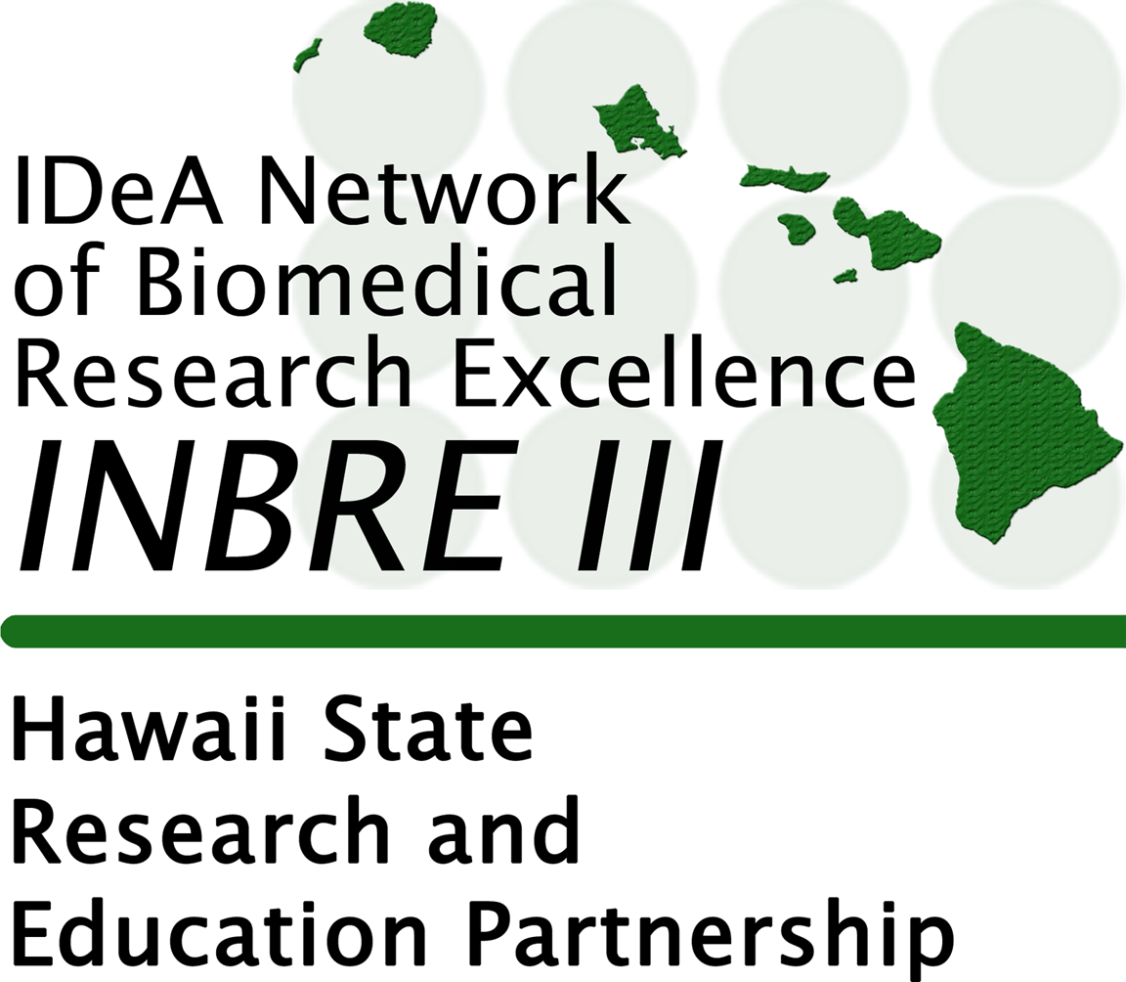

Our goal is to standardize all safety training across INBRE using the NIH training program. Student certification, once completed, must be email to INBRE (INBRE@hawaii.edu).

NIH Lab safety training: https://www.safetytraining.nih.gov/

When registering to take a class, you will be required to fill out a profile (do not use eCommons login). The required fields below should be chosen:

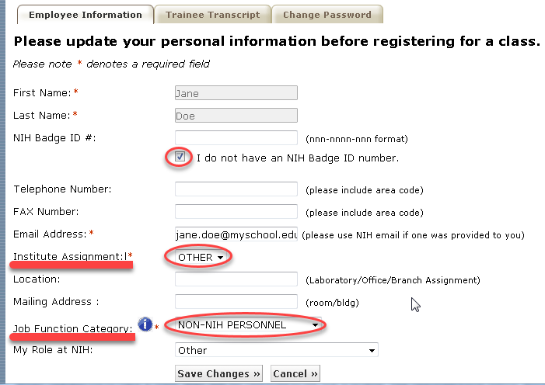
https://www.safetytraining.nih.gov/default.aspx?m=Please-Log-In

These two (2) will be required
· Introduction to Lab Safety - On-Line Training
· NIH Laboratory Safety Training 101 (not for Baltimore Research Center personnel)

This one is specific to the needs of research, as assessed by the mentor/PI, but not mandatory for all students
· Working Safely with HIV and Other Bloodborne Pathogens (for Non-Hospital Personnel) ON LINE

These two (2) will be used for returning students, yearly update/re-certification
· Laboratory Safety Refresher Course - On-line Training
· Bloodborne Pathogen Refresher Course - On-line Training

A GUIDE to INBRE Student Milestones
Three (3) Cycles per year mechanism (Summer/Fall/Spring). A new application is required each cycle.
Cycle | Milestones | Student Learn Objectives | Evaluated Outputs
1 | Safety Awareness and training  Understanding the professional  responsibilities and expectations of  becoming a scientific researcher  Discussion of research project  Establish preliminary Research Plan  Laboratory orientation  Commencement of scientific research | Obtain safety training  Understanding of the scientific method  Understanding the mechanism of experimental  design  Understand background literature  Development of a professional working  relationship with mentor(s)  Obtain familiarity with a working research laboratory environment | NIH / campus safety training certificates  Familiarity with background literature  Written preliminary Research Plan  Scheduled meetings with mentor(s)  Submission of Reflection paper  Completed evaluations and surveys
2 | Safety Awareness and training  Stated hypothesis  Established Research Plan  Commencement of data gathering  Draft of INBRE poster | Maintain safety compliance  Stated importance/impact of research project  Understanding the importance of data  presentation (Data, Tables and Graphs)  Development of effective communications skills | NIH / campus safety training certificates  Research hypothesis  Preliminary results  Participation in laboratory meetings /  presentations/updates etc.  Submission of Reflection paper  Completed evaluations and surveys
3 | Safety Awareness and training  Continued data collection  Focus on formal scientific writing  Completion of INBRE poster - Draft  Draft introduction for scientific paper  Refinement of reflection paper | Maintain safety compliance  Enhancement of effective communication skills  (verbal and written)  Demonstration of scientific writing – manuscript  preparation  Meet targets for preparation for INBRE  symposium | NIH / campus safety training certificates  Draft of research poster  Demonstrated communication skills  verbal [poster, lab and group meetings];  written [poster, papers]  Submission of Reflection paper  Completed evaluations and surveys
Future Cycles | Safety Awareness and training  Accelerated data gathering  Refinement of Results/Data  Updating INBRE poster | Maintain safety compliance  Expand upon scientific writing and data  processing  Meet targets for preparation of Draft paper for  manuscript submission  Compile introduction, methods and results for  scientific paper | NIH/campus safety training certificates  Demonstrated results (refined Tables /  Graphs)  Submission of Reflection paper  Completed evaluations and surveys  Submission of scientific paper

